

READ THESE INSTRUCTIONS FIRST

Write in soft pencil
Write your name, class and student number on the answer sheet in the spaces provided.
Do not use staples, paper clips, highlighters, glue or correction fluid.

There are forty questions in this paper. Answer all questions. For each question there are four possible answers A, B, C and D.
Choose the one you consider correct and record your choice in soft pencil on the separate answer sheet.

Read the instructions on the answer sheet very carefully.

Each correct answer will score one mark. A mark will not be deducted for a wrong answer.
Any rough working should be done in this booklet.

CAMBRIDGE ‘A’ LEVEL PROGRAMME

SEMESTER ONE EXAMINATION NOVEMBER/DECEMBER 2007
(JULY 2007 Intake)

Wednesday 5 December 2007 8.30 am – 9.30 am

PHYSICS 9702/01

PAPER 1 Multiple Choice 1 Hour

Additional Materials: Multiple Choice Answer Sheet
Data Booklet
This document consists of 14 printed pages.

© Taylor’s University College Subang Jaya 2007 [Turn over
1 Student measures a current as 5 A.
Which of the following correctly expresses this result?

A 5000 mA B 5000 MA C 500 mA D 500MA

2 Which of the following could be measured in the same units as momentum?

A energy / velocity
B energy x distance
C energy / time
D Force x distance

3 Which of the following could be the greatest length?

A 5000 mm B 500 Km C 50000 m D 50 Tm

4 The following trace is seen on the screen of a cathode-ray oscilloscope.
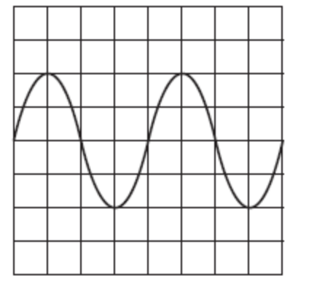

The setting of the time base is then changed from 10 ms cm^{–1} to 5 ms cm^{–1}and the Y- sensitivity is unaltered. Which trace is now seen on the screen?
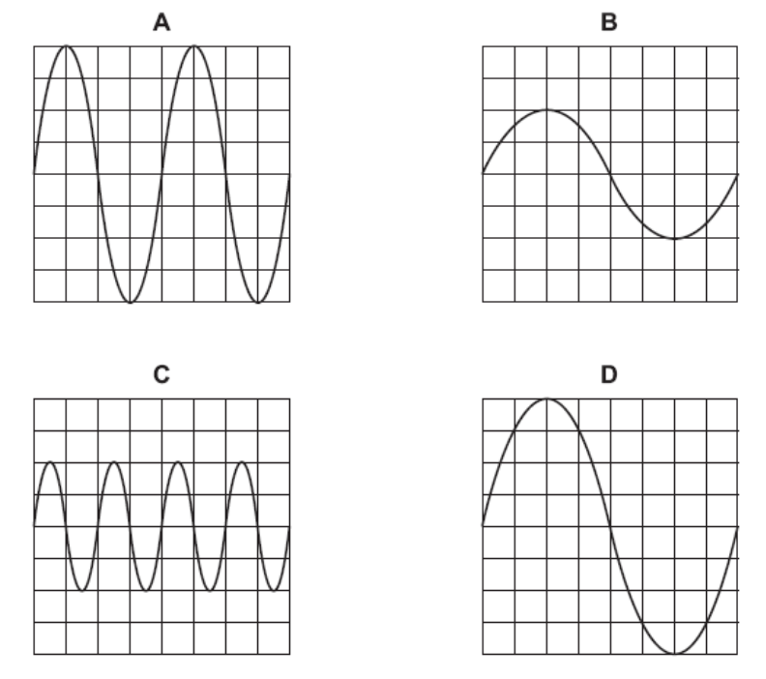

5 Which statement below is the proper method to write a result with its uncertainty?

A (2.60 0.001) m
B (26.0 0.01) m
C (260 10.0) m
D (0.026 0.001) m

6 The density of the material of a rectangular block is determined by measuring the mass and linear dimensions of the block. The table shows the results obtained, together with their uncertainties.

mass = (25.0 ± 0.1) g
length = (5.00 ± 0.01) cm
breadth = (2.00 ± 0.01) cm
height = (1.00 ± 0.01) cm

The density is calculated to be 2.50 g cm^{–3}. What is the uncertainty in this result?

A ± 0.01 g cm^{–3} B ± 0.02 g cm^{–3} C ± 0.05 g cm^{–3} D ± 0.13 g cm^{–3}

7 A car at rest in a traffic queue moves forward in a straight line and then comes to rest again. The graph shows the variation with time of its displacement. What is its average speed for 140 seconds?
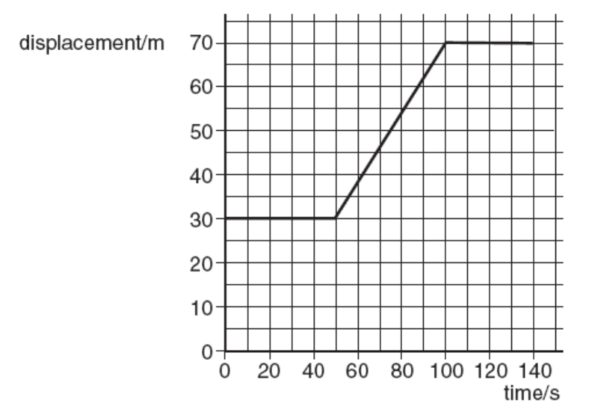

A 0.30ms^{–1} B 0.80ms^{–1} C 1.20ms^{–1} D 1.40ms^{–1}

8
Q
P

The above figure shows two vector P and Q. Which of the following vector diagram shows the correct direction for the vector R, where R = P - Q

A. B.
R
P
Q
P

R

Q

C. D.
P
P

Q

Q
R
R

9.
0
-2
Time t /s
2 4 6 8 10
2 -
4 ⁻
Position/m

In demonstrating a dance step, a person moves in one dimension as shown in above graph. What is the average speed between time, t = 4 s and t = 8 s.

A. 0.50 ms⁻¹ B. 0.67 ms⁻¹ C. 1.50 ms⁻¹ D. 2.00 ms⁻¹

10. A long narrow tube contains salt water of density 1020 kgm⁻³ to a depth of 1 m. The tube is then inclined at 30⁰ to the horizontal. If atmospheric pressure is 100 kPa, what is the pressure at the bottom of the tube?

A 105 kPa C 110 kPa
B 100 kPa D 1020 kPa

11. Two balls X and Y approach each other along the same straight line and collide elastically.Their speeds are U_{X} and U_{Y} respectively. After the collision they move apart with speeds V_{X} and V_{Y} respectively. Their directions are shown on the diagram.
Which of the following equations is correct?

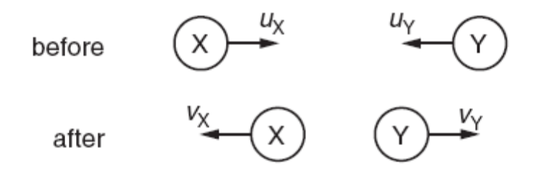

A U_{X} +U_{Y} = V_{X} +V_{Y}
B U_{X} +U_{Y} =V_{X} –V_{Y}
C U_{X} –U_{Y} =V _{Y} +V _{Y}
D U_{X} –U_{Y} =V_{X} –V_{Y}

12 A molecule of mass m travelling horizontally with velocity u hits a vertical wall at right angles to the wall. It then rebounds horizontally with the same speed.
What is its change in momentum?

A zero B mu C mu D 2mu

13 A motorcycle stunt-rider moving horizontally takes off from a point 1.25 m above the ground, landing 10 m away as shown.

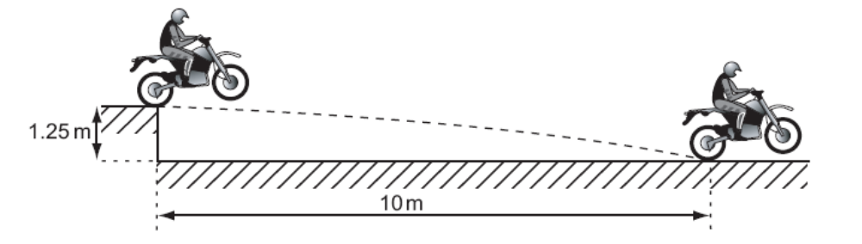
What was the speed at take-off?

A 5 m s^{–1}
B 10 m s^{–1}
C 15 m s^{–1}
D 20 m s^{–1}

14 A stone is dropped from the top of a tower of height 80 m. The stone falls from rest and air resistance is negligible. What time is taken for the stone to fall the last 20 m to the ground?

A 0.38 s B 0.54 s C 2.5 s D 2.9 s

15 Which of the following pairs of forces, acting on a circular object, results to the greatest resultant moment about the center of the object?

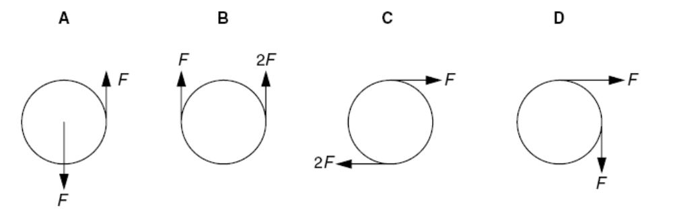

16 At a depth of 20 cm in a liquid of density 1800 kgm^{–3}, the pressure due to the liquid is p. Another liquid has a density of 1200 kgm^{–3}.
What is the pressure due to this liquid at a depth of 60 cm?

A 2p B 3p C p/2 D 3p/2

17 Which in the table gives approximate ratios of density and molecular spacing for a substance in its solid, liquid and gas phases?

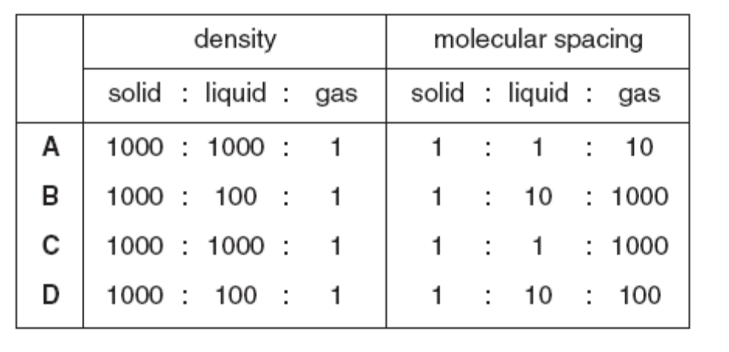

18 A twig from a tree drops from a 200m high cliff on to a beach below. During its fall, 50 % the twig’s energy is converted into thermal energy.
What is the speed with which the twig hits the beach?

A 35ms^{–1} B 40 ms^{–1} C 45 ms^{–1} D 50 ms^{–1}

19 An area of land is an average of 2.0m below sea level. To prevent flooding, pumps are used to lift rainwater up to sea level.
What is the minimum pump output power required to deal with 1.3 x 10⁹ kg of rain per day?

A 15 kW B 30 kW C 150 kW D 300 kW

20 A car with a total mass of 1400 kg is travelling at 30 m s^{–1.}
What is the kinetic energy of the car?

A 21 kJ B 42 kJ C 630 kJ D 1260 kJ

- A piece of copper is drawn into a continuous wire.
What behaviour is the copper exhibiting?

A brittle only C elastic only
B plastic only D both brittle and plastic

- Which of the following correctly defines the terms stress, strain and Young modulus?

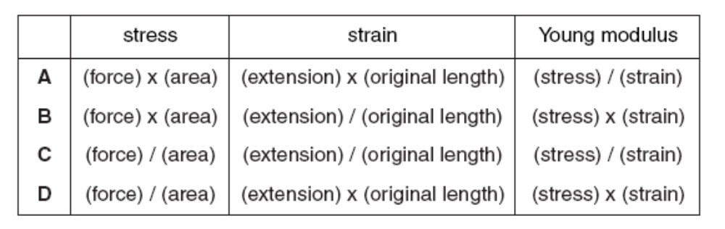

- The tension in a spring of natural length l₀ is first increased from zero to T₁, causing the length to increase to l₁. The tension is then reduced to T₂, causing the length to decrease to l₂ (as shown).

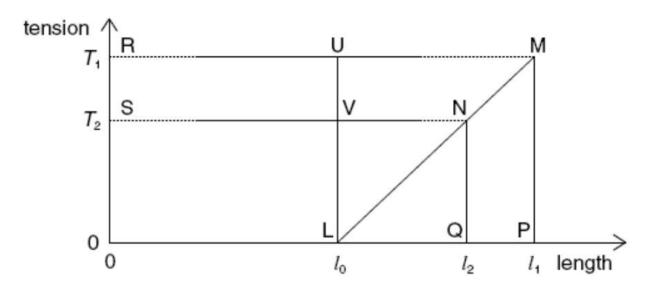

Which area of the graph represents the work done by the spring during this reduction in length?

A MPLU C MNQP
B MNSR D MLP

- The diagram shows a cathode-ray oscilloscope trace of a sound wave. The time-base is calibrated at 4.0ms cm^{–1}.

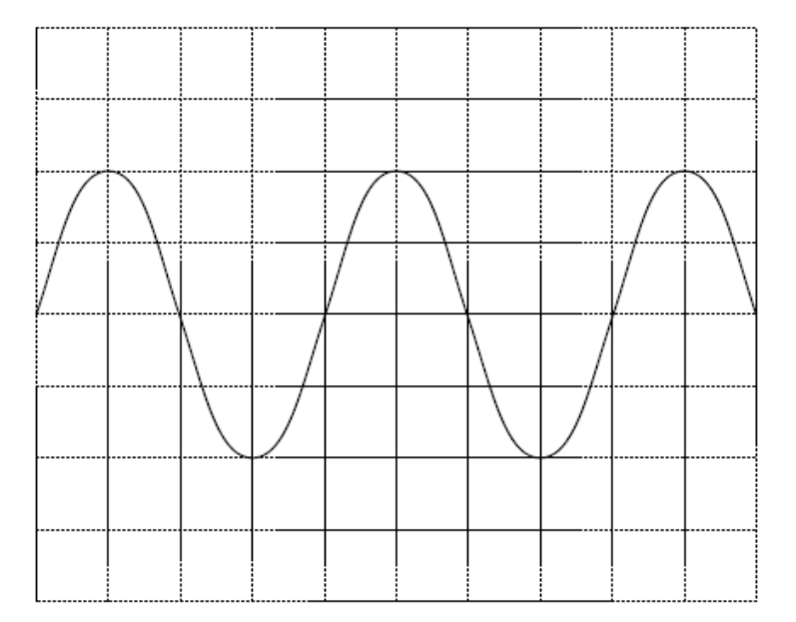

What is the frequency of the sound wave?

- 62.5 Hz
- 125 Hz
- 250 Hz
- 500 Hz

- Which statement correctly relates the intensity of a sound wave to the vibrations of the molecules?

A intensity α amplitude
B intensity α (amplitude)²
C intensity α displacement
D intensity α (displacement)²

- The diagram represents a progressive wave moving from left to right.
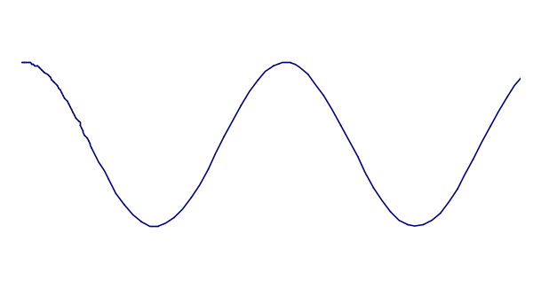

Displacement

Y

0
time

0

X

What is the phase difference between X and Y?

A π/4 rad B π/2 rad C π rad D 2π rad

- Monochromatic light of wavelength 590 nm is incident normally on a diffraction grating. The angle between the two second-order diffracted beams is 43°. What is the spacing of the lines on the grating?

A 0.87 μm C 1.7 μm
B 1.6 μm D 3.2 μm

- An electric field exists in the space between two charged metal plates.
Which graph shows the variation of electric field strength E with the separation d between the plates?

+
−

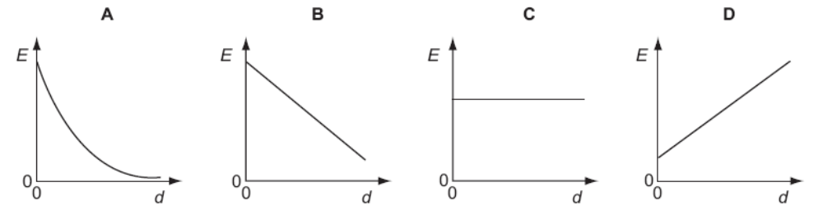

- A proton, travelling horizontally at constant speed in a vacuum, enters a vertical electric field between two charged parallel plates as shown.

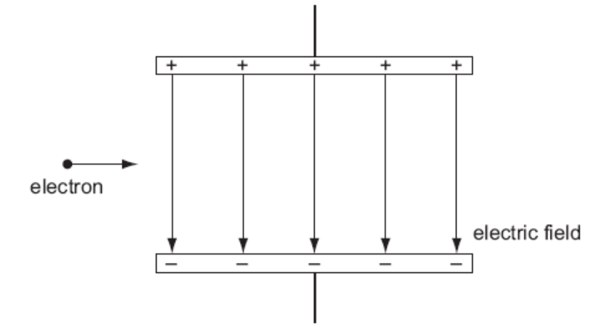
proton
What are the horizontal and vertical components of the motion of this proton when it is in the field?

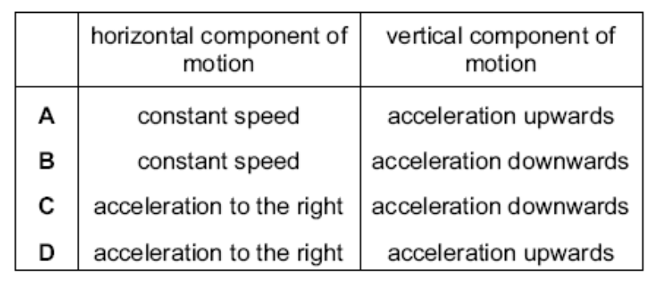

- The variation with potential difference V of the current I in a semiconductor diode is shown below.

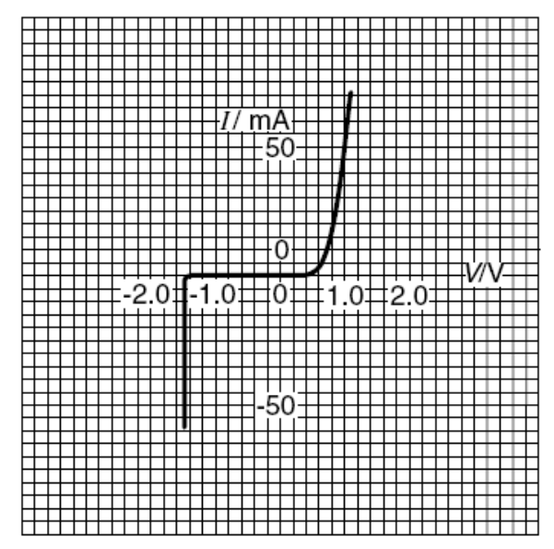

What is the resistance of the diode for applied potential differences of +1.0 V and –1.0 V?

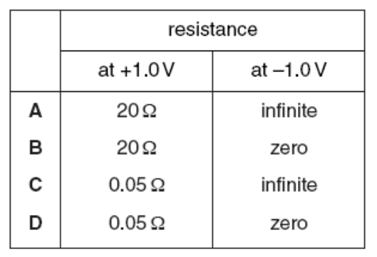

- Which circuit has a resistance of 40 Ω between the terminals?

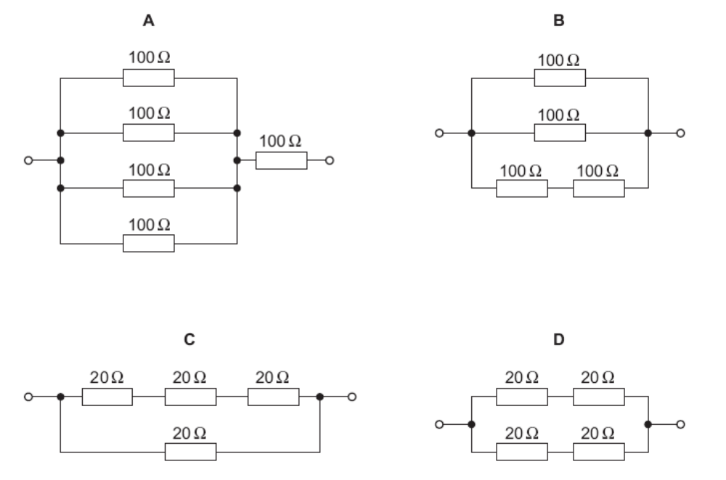

- The diagram represents a circuit.

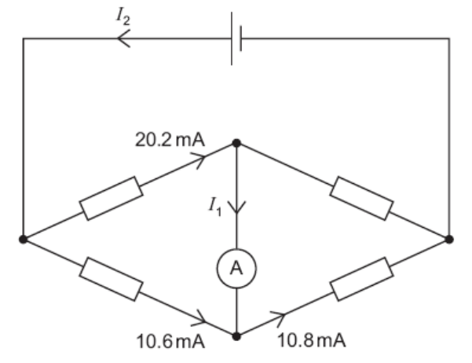

Some currents have been shown on the diagram.
What are the currents I₁ and I₂?

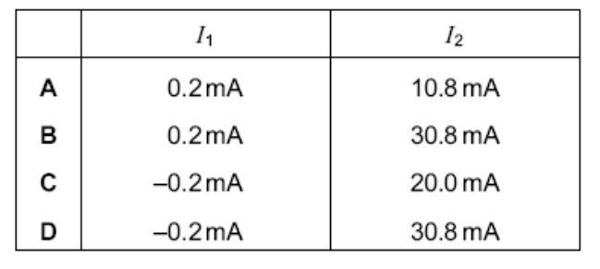

- The diagram shows a potentiometer and a fixed resistor connected across a 12 V battery of negligible internal resistance.

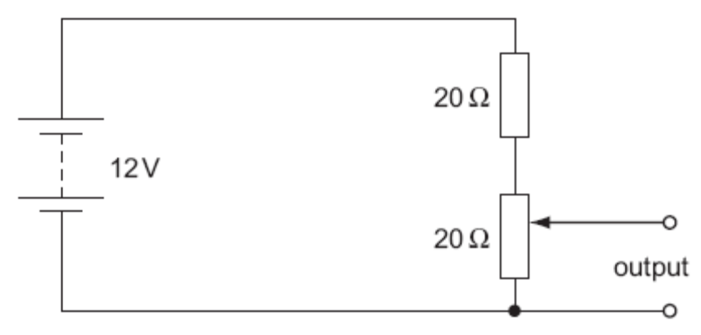
10 Ω
The fixed resistor has a resistance of 20 Ω and the potentiometer has a resistance of 10 Ω. The circuit is designed to provide a variable output voltage. What is the range of output voltages?

A 0 – 12 V B 6 -12 V C 4 – 12 V D 0 - 4 V

- The resistance of a device is designed to change with light intensity. What is the device?

A A light-dependent resistor
B A semiconductor diode
C A thermistor
D A potential divider

- What physical quantity would result from a calculation in which a potential difference is multiplied by an electric charge?

A electric current
B electric power
C electric field strength
D electric energy

- The e.m.f. of the cell in the following circuit is 9.0 V. The reading on the high-resistance voltmeter is 7.5V.

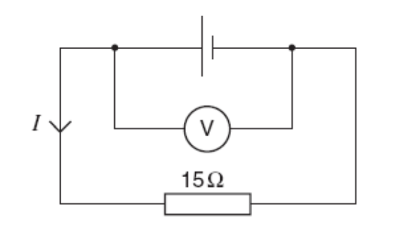
What is the current I ?

A 0.1 A B 0.5 A C 0.60 A D 2 A

- Where are electrons, neutrons and protons found in an atom?

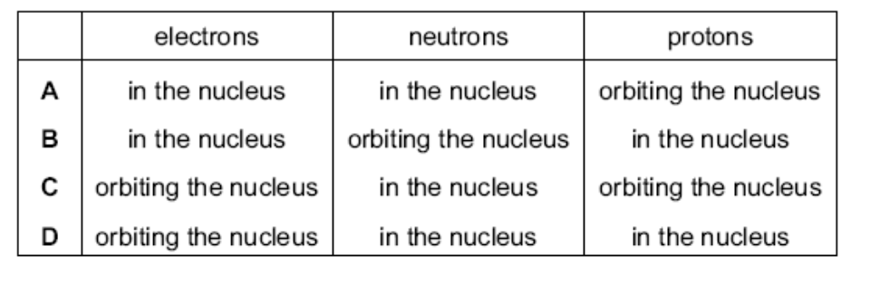

- Each of the nuclei below is accelerated from rest through the same potential difference. Which one completes the acceleration with the highest speed?

A 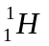 B 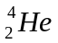 C 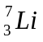 D 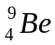

- What is a correct order of magnitude estimate for the diameter of a typical atomic nucleus?

A 10⁻¹⁴ m B 10⁻¹⁸ m C 10⁻²² m D 10⁻²⁶ m

- A nuclear reaction is represented by the equation.

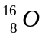 + 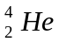 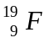 + X

What is particle X?

A An alpha particle
B A beta particle
C A neutron
D A proton

